How to translations for CAcert applications
CAcert is using Pootle as tool to do the translations.
The starting page is http://translations.cacert.org.
After logging into the page the available languages are displayed.
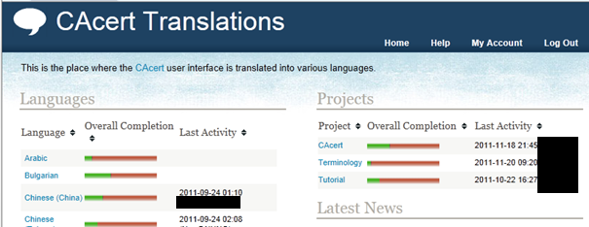
Select the desired language on the left part of the page.
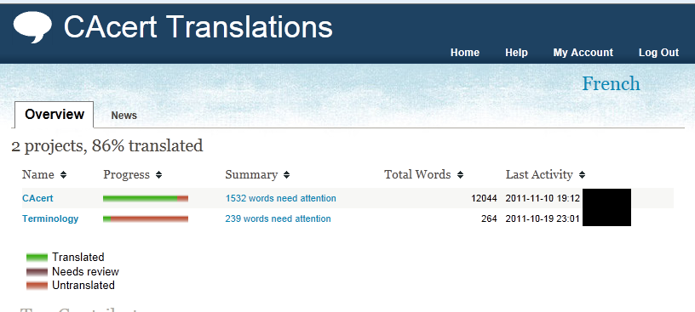
The different projects are displayed.
At the moment of writing this document the project CAcert is the important one as it holds the translations for the main web interface of CAcert where the data is stored.
Select the project
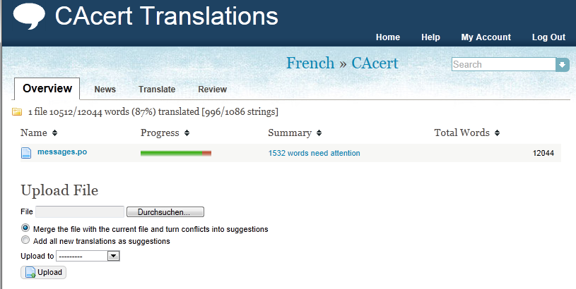
The tab Overview gives basic information about actual translation.
The tab News you find information about the changes done to the translation file.
On the tab Translate you will do the actual translation (see below)
The tab Review gives a list of elements that needs attention by their type e.g. unchanged text.
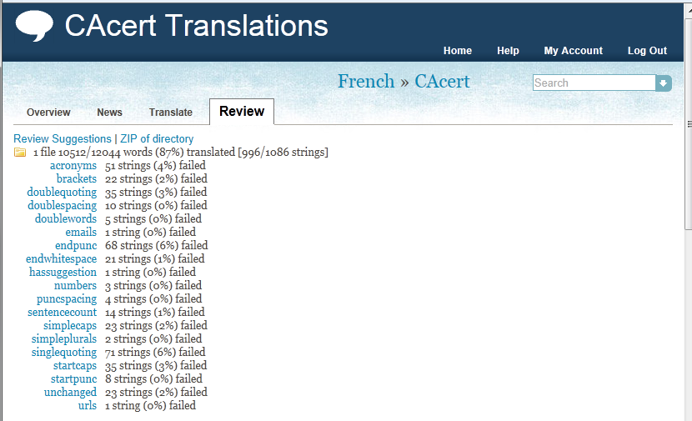
By clicking on an element you get a filter for the topic and will be able to navigate just through the texts hat match the filter criteria.

Search for a certain phrase
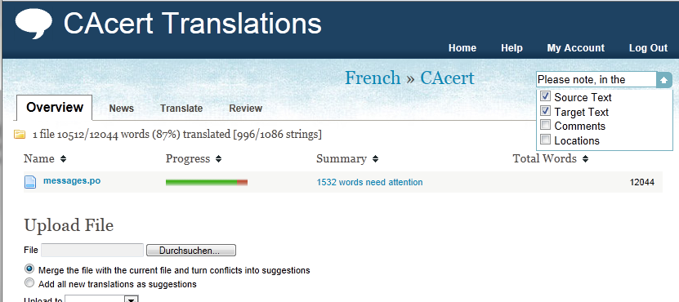
To search for a certain phrase you place the text in the search box at the right top of the page. By opening the dropdown box the location where the search should take place can be defined.
To start the search use Enter.

Translation
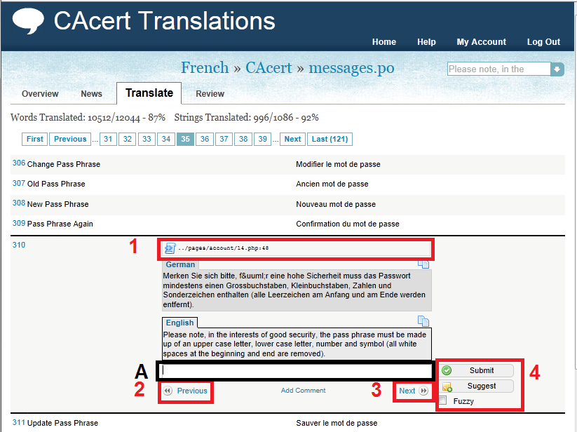
At A the translation is placed.
At 1 the place is given where the phrase is used in the source code. You might want to check the context there.
At 2 and 3 the navigation through the entries is done. If a filter is applied the next element matching the filter criteria is shown. e.g. search phrase or review subject
At 4 the saving of the data is performed. Submit is changing the data that will be used in the translated view of the software.
Suggestion marks an alternative phrase but the one marked with translation is used.
Fuzzy is used to point out that other translators should review the entry.

more information:
http://www.CAcert.org
http://wiki.CAcert.org
There are some IRC-chat channels for different languages on
IRC-Server: irc.CAcert.org (SSL-Port: 7000)
Channels: #CAcert (English)
#CAcert.ger (German)
#CAcert.fr (French)
and a web interface on http://irc.CAcert.org.
Support E-mail: CAcert-support@CAcert.org
Support information:
http://wiki.CAcert.org/wiki/GettingSupport

Version
No | Author | Date
1.0 | INOPIAE | 2011-11-20

