
How much does CAcert cost?

Support
Email: cacert-support@lists.cacert.org
IRC channel: #cacert on server irc.cacert.org

Fingerprints

CAcert Root certificate
SHA1: 13:5C:EC:36:F4:9C:B8:E9:3B:1A:B2:70:CD:80:88:46:76:CE:8F:33
MD5: A6:1B:37:5E:39:0D:9C:36:54:EE:BD:20:31:46:1F:6B

CAcert Class 3 Root certificate
SHA1: AD:7C:3F:64:FC:44:39:FE:F4:E9:0B:E8:F4:7C:6C:FA:8A:AD:FD:CE
MD5: F7:25:12:82:4E:67:B5:D0:8D:92:B7:7C:0B:86:7A:42
Flyer-2s-3c-En 2.02 rev. 01 (June 2011)
© 2011 CAcert. All rights reserved.
Digital certificates
for Individuals
and Organisations
client certificates
server certificates
code signing
X.509  SSL/TLS  S/MIME
PGP  GnuPG  OpenPGP
http://www.cacert.org
http://www.cacert.org
The certificates are free of charge.
Thanks to many volunteers running CAcert and highly automated services, CAcert can operate very cost effectively. Your donations help to cover CAcert operating costs, and are greatly appreciated.

How can I support CAcert?
- Become a CAcert community member and use CAcert certificates
- Take part in the CAcert Assurer Challenge and become a CAcert Assurer
- Support CAcert at events, spread the word
- Help with CAcert’s core processes, e.g. system administration or support

See: http://wiki.cacert.org/HelpingCAcert.

Where can I find further information?
For more information visit the official CAcert web site: http://www.cacert.org

Documentation is available on the CAcert wiki:
http://wiki.cacert.org

CAcert has some IRC chat channels on irc.cacert.org where you can feedback on CAcert services, get support, or just talk to community members.

Channels: #cacert (English)
#cacert.ger (German)
#cacert.fr (French)

For secure chat, use SSL port 7000.

Don’t have an IRC client? Use the web interface on http://irc.cacert.org

Support email:
cacert-support@lists.cacert.org

Support information:
http://wiki.cacert.org/GettingSupport
Digital Certificates

What is CAcert?
CAcert is a community-based, non-profit organisation registered in Australia.

CAcert’s objectives are:
to enhance security in the IT era
to support users in their security efforts
to supply tools and mechanisms for IT security

Fields of application include:
securing web servers using HTTPS signing and encrypting electronic mail
SSL/TLS server applications web site communication
VPN communication
code signing (e.g. Java)
digital signing of documents
CAcert aims to make security freely available for the IT world and make the security means affordable to everyone. CAcert is an open community and uses the Open Source philosophy to achieve her goals.

Why should I join?

Security:
Enable security for yourself and other internet
users.

Privacy:
CAcert certificates help to maintain your privacy
on the internet.

Authentication:
Prove that your identity has been checked and that you really are who you say you are.

Free email and server certificates
X.509 certificates are used to sign emails using S/MIME and to allow servers, such as web and mail servers, to provide secure connections. Other certification authorities usually demand high charges for fulfilling the tasks of a trust center: checking your identity and whether a web site or email address really belongs to you. CAcert offers this for free.

How does CAcert work?
To join CAcert you need to create a personal account on http://www.cacert.org. You only need to specify your full name, date of birth and email address. You can add an unlimited amount of email addresses for client certificates and domain names for server certificates to your account later.
After that you can start issuing certificates yourself using the web interface at will. In order to have your name in the certificate you need to have your identity checked. Get in touch with assurers (e.g., by using the assurer search on the web site) or meet them at an event.

Free PGP key signing
Do you have PGP/GnuPG/OpenPGP keys? Once you have been assured you can have your keys signed by the CAcert PGP key.
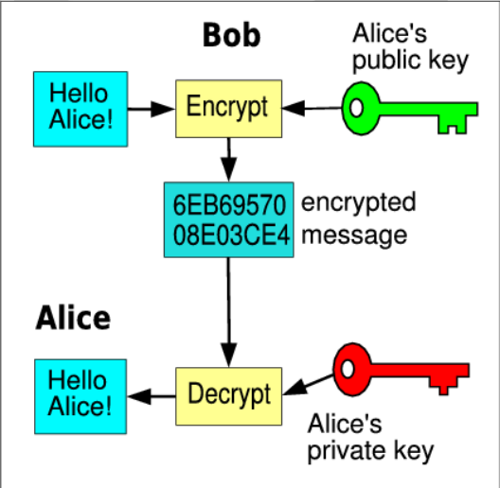
How public key encryption works

Code signing
You can digitally sign your software using CAcert certificates to identify and authenticate it.

Organisation assurance
For companies and other organisations CAcert has an Organisation Assurance Programme. Once assured, certificates containing the name of the organisation can be issued at will and the employees of the organisation can have their own certificates issued by the organisation.

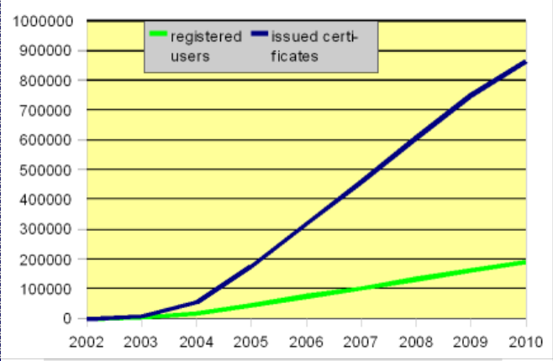
CAcert’s growth since foundation in 2002

What software supports CAcert certificates?
You can use CAcert client certificates in all software capable of X.509 (S/MIME) certificates.
Some examples:
Microsoft Outlook and Office
Mozilla Thunderbird and Firefox
OpenOffice.org
You can use CAcert server certificates in all software capable of SSL-based certificates.
Some examples:
Apache web server
Microsoft Internet Information Services
Mailservers (e.g. Postfix, Sendmail, Courier)
OpenSSL/OpenVPN

